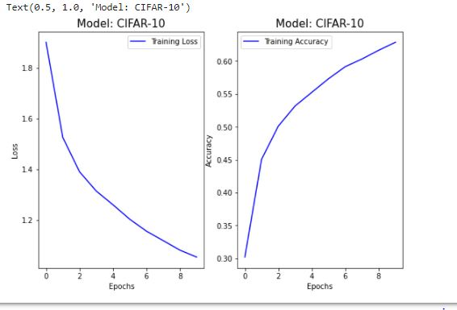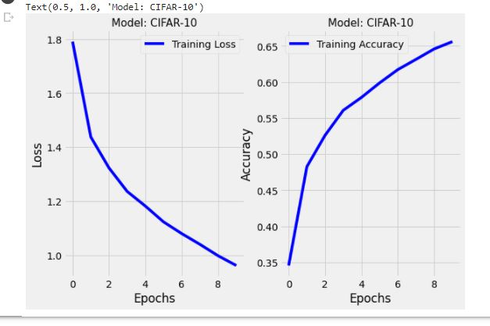

Figure2 LeNet CNN with batch size of 128 and accuracy = 0.64

Figure 1 LeNet CNN with batch size of 64 and accuracy = 0.67

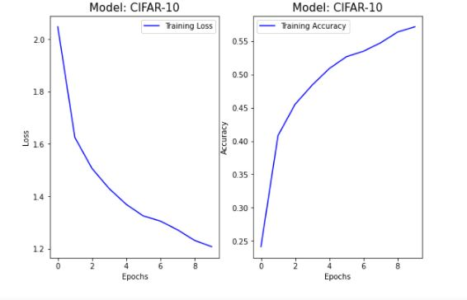

Figure 3 LeNet CNN with batch size of 256 and accuracy = 0.58